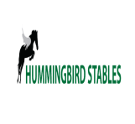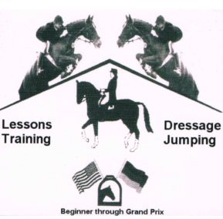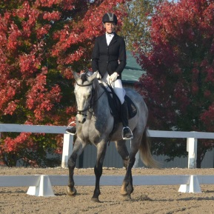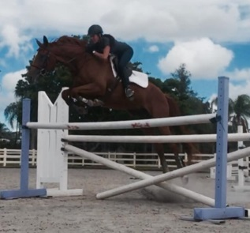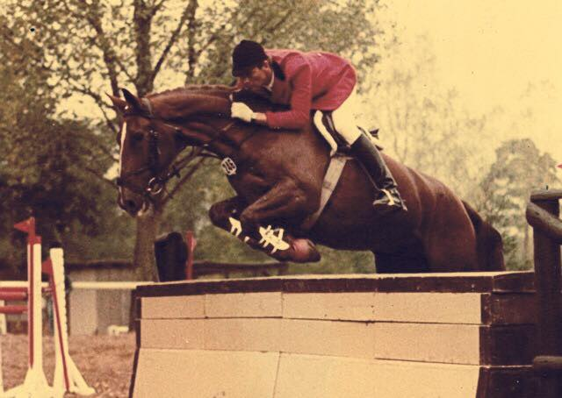

Learn from the BEST – Be ready for Show Season 2016!

AM DRESSAGE - PM JUMPER (75 MINUTES EACH)

1. Beginner Novice Dressage / Training Dressage  
 JUMPERS - Beginner Novice / 2’- 2’6

2. Novice Dressage / First Level Dressage  
 JUMPERS - Novice / 2’6 - 3’

3. Training/Prelim Dressage / 2nd Level

JUMPERS - Training/Prelim - 3’- 3’6” and UP

May 28-30 2016

HALF SESSION (JUMPING OR DRESSAGE)  
$250 per student   
  
FULL SESSION (BOTH JUMPING & DRESSAGE)  
$425 per student

**Stalls available additional *or* Haul IN free**   
 RSVP by 4/1/16. Limited Space Available

TRAINER AMY NELSON

[Amy@amynelsonequestrian.com](mailto:Amy@amynelsonequestrian.com)

217.553.2937  
Hummingbird Stables  
Rochester, il

**May 28-30, 2016  
Memorial Weekend  
Sat/Sun/Mon**

### **JUMPING & DRESSAGE CLINIC**

**WITH WORLD RENOWNED GRAND PRIX TRAINER PETER TRAPPMAN  
His Students Represented the German Olympic Team. ARE YOU READY?**

# peter trappmann **clinic**